RED KNIGHTS MOTORCYCLE CLUB ®
Alabama Chapter 14
Misty Ogle - QUARTERMASTER
4009 Sandor Dr
Boaz Al, 35956
Tel. 256-572-5542
E-Mail: al14@redknightsmc.com
TMLA File Number 14-03, 14-06
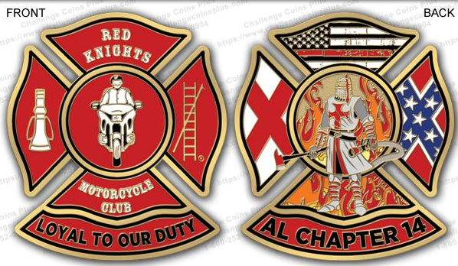
AL Chapter 14 Challenge coin. 2 sided coin with international logo and Moto on the front, Alabama chapter 14 logo on the back. Shipping is included to the continental U.S. (add $15 shipping for all international orders). Pay Pal is accepted. E-mail for more information

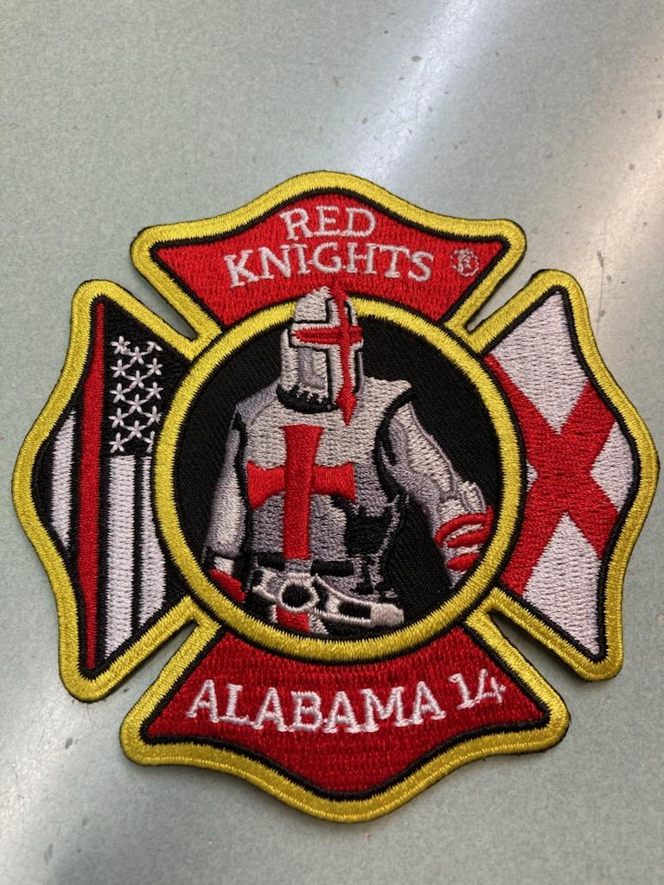
AL Chapter 14 chapter patch.. 4 inch patch. Pay Pal is accepted. Shipping is included to the continental U.S. add $2.50 shipping for all international orders).E-mail for more information

Item | Description | Color | Quantity | Cost ea. | Total
1 | AL14 challenge coin | multi |  | $15
2 | AL14 Chapter patch | multi |  | $10
Sub Total
Shipping and handling fees (if any)
Total

Please make check/money order out to (Red Knights AL14)
All items MUST be prepaid. Item will be shipped once payment has cleared
All Prices US currency / Prices subject to change without notice

