RED KNIGHTS MOTORCYCLE CLUB ®
Virginia Chapter 5
Eric Scott - QUARTERMASTER
E-Mail: VA5@redknightsmc.com
TMLA File Number Virginia 05-02

In an attempt to have uniformity in the International Catalog PLEASE do not change colors, fonts and layout of the above header.

Order your Custom Red Knights thin red line badge. $100.00 for badge $10 for shipping and handling. Your chapter will be engraved on badge. Please visit RedKnightsVa5.com to place all orders.

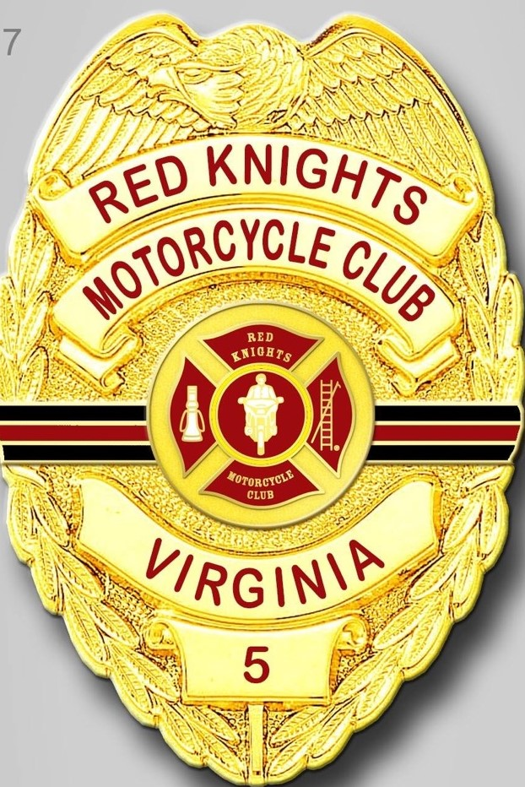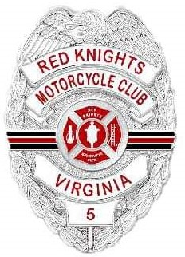


Visit RedKnightsVa5.com to place all orders
If outside of the United States, please combine chapter orders and ship to one address for local distribution.
Please allow 6-8 weeks for delivery of items not in stock
All Prices US currency / Prices subject to change without notice

