RED KNIGHTS MOTORCYCLE CLUB ®
North Carolina 24
Anita Talbert- QUARTERMASTER
21863 Canton Rd
Albemarle, NC 28001
Tel. 704-699-4077
E-Mail: rkmc24quartermaster@yahoo.com
TMLA File Number North Carolina 24-06
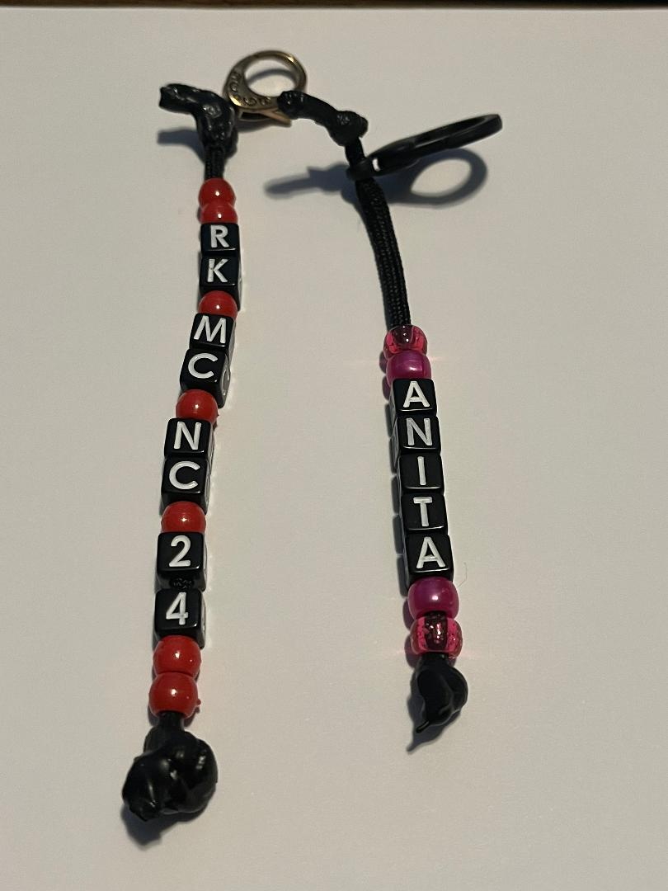
These bead strands are handmade and personalized. 1st strand will have RKMC, State and Chapter number. 2nd strand will have your name of choice.

☐Automotive
☐Automotive-Misc
☐Automotive-Motorcycle
☐Coin, Patches, Pins
☐Clothing
☐Clothing-Hats
☐Clothing-Misc
☒Clothing-Vest/Vest Items
☐Clothing-Women’s
☐Decals/Stickers
☐Flags
☐Housewares-Beverage Items
☐Housewares-Misc.
☐Misc. Items

Item | State and Chapter number | Name of Choice | Quantity | Cost ea. | Total
1 |  |  |  | $10.00
2 |  |  |  | $10.00
3
4
Sub Total
Shipping and handling fees (if any) |  |  |  |  | $5.00
Total
Please make check/money order out to RKMC NC 24 or PayPal account @rkmcnc24
Please allow 6-8 weeks for delivery of items not in stock
All Prices US currency / Prices subject to change without notice
All items MUST be prepaid

