RED KNIGHTS MOTORCYCLE CLUB ®
North Carolina 24
Anita Talbert- QUARTERMASTER
21863 Canton Rd
Albemarle, NC 28001
Tel. 704-699-4077
E-Mail: rkmc24quartermaster@yahoo.com
TMLA File Number North Carolina 24-03
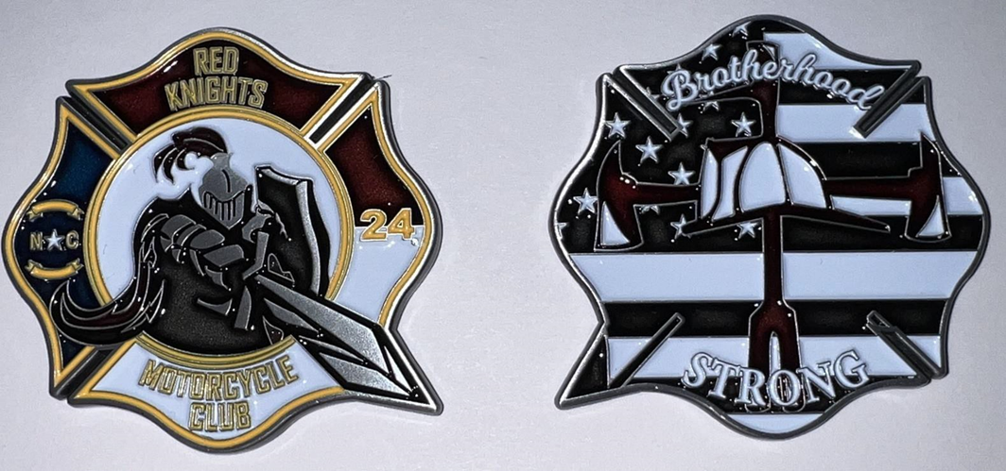

☐Automotive
☐Automotive-Misc
☐Automotive-Motorcycle
☒Coin, Patches, Pins
☐Clothing
☐Clothing-Hats
☐Clothing-Misc
☐Clothing-Vest/Vest Items
☐Clothing-Women’s
☐Decals/Stickers
☐Flags
☐Housewares-Beverage Items
☐Housewares-Misc.
☐Misc. Items

Item | Description | Color | Quantity | Cost ea. | Total
1 | NC Chapter 24 Challenge Coin Brotherhood Strong |  |  | $10.00
2
3
4
Sub Total
Shipping and handling fees (if any) |  |  |  |  | $5.00
Total
Please make check/money order out to RKMC NC 24 or PayPal account @rkmcnc24
Please allow 6-8 weeks for delivery of items not in stock
All Prices US currency / Prices subject to change without notice
All items MUST be prepaid

