**RED KNIGHTS MOTORCYCLE CLUB ®**

**NH Chapter IV**

**Tim Fiske - QUARTERMASTER**

**328 General Miller Highway**

**Temple, NH 03084**

**Tel. 603-396-0857**

**E-Mail: tfiskeconst@gmail.com**

**TMLA File Number NH 04-01**

**Red Knights NH IV is offering to the membership these attractive chrome License Plate Frames, available in two sizes – Full Size Auto Frame and Motorcycle Plate Frame. The Red Knights Logo is proudly displayed for all to know your affiliation.**

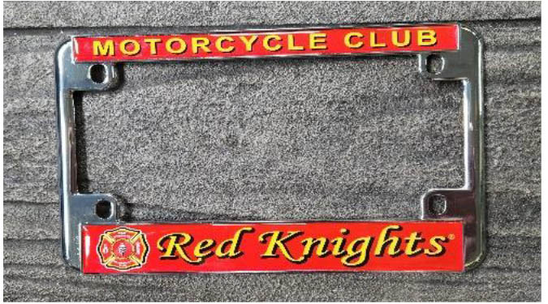

Automotive

Automotive-Misc

Automotive-Motorcycle

Coin, Patches, Pins

Clothing

Clothing-Hats

Clothing-Misc

Clothing-Vest/Vest Items

Clothing-Women’s

Decals/Stickers

Flags

Housewares-Beverage Items

Housewares-Misc.

Misc. Items

|  |  |  |  |  |  |
| --- | --- | --- | --- | --- | --- |
| **Item** | **Description** | **Color** | **Quantity** | **Cost ea.** | **Total** |
| **1** | Full Size Auto Frame |  |  | $25.00 |  |
| **2** | Motorcycle Plate Frame |  |  | $25.00 |  |
|  |  |  |  |  |  |
|  | Shipping & Handling within the Lower 48 States |  |  | $6.00 |  |
|  | Alaska, Hawaii, Canada and International |  |  | Call for price |  |
|  |  |  |  |  |  |
| **Sub Total** | | | | |  |
| **Shipping and handling fees (if any)** | | | | | See above |
| **Total** | | | | |  |

Pay with Paypal @RKChpt4  
Please make check/money order out to **NH Chapter IV**

Please allow 6-8 weeks for delivery of items not in stock

All Prices **US currency** / Prices subject to change without notice

All items MUST be prepaid

Please include your name, address, and phone number or email address