RED KNIGHTS MOTORCYCLE CLUB ®
Penssylvania 31
Dustin Crane - QUARTERMASTER
93 McKinstry Hill Road
Apollo PA, 15613
Tel. 725-549-5491
E-Mail: Craned19@gmail.com
TMLA File Number PA 31-04

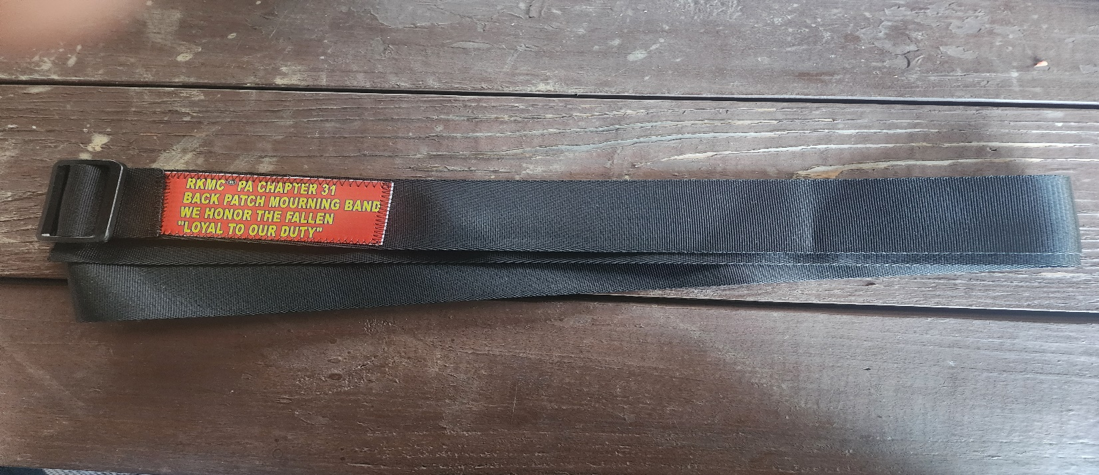
In an attempt to have uniformity in the International Catalog PLEASE do not change colors, fonts and layout of the above header. Please follow all directions so that you item can be posted quickly.

Cut and Paste photos and descriptions of your item(s) here. Your photos should cover these words that are in Grey highlight. DO NOT send them separately, it needs to be all together one sheet.

Below is a table that can be used as an order form if you have multiple items listed. Be sure that the text at the bottom of the page is accurate for your chapter. Make any changes in the fine text and or order form as may be needed by your chapter.

If this is a new item, you must have a TMLA for the item(s). If you do not, you must use the Trademark License Application form found on the downloadable Files page and apply for one. If this is just a change of name or address for an item currently on the merchandise web page, send a NEW completed form to the Communications Chair at communications@redknightsmc.com

Please check which category your item should be displayed in. Only pick one category. If you choose more than one your form will be sent back for correction.

☐Automotive
☐Automotive-Misc
☐Automotive-Motorcycle
☐Coin, Patches, Pins
☐Clothing
☐Clothing-Hats
☐Clothing-Misc
☒Clothing-Vest/Vest Items
☐Clothing-Women’s
☐Decals/Stickers
☐Flags
☐Housewares-Beverage Items
☐Housewares-Misc.
☐Misc. Items

Item | Description | Color | Quantity | Cost ea. | Total
1 | Back Patch Mourning Band | black |  | $20
2 | Item
3 | Item
4 | Item
Sub Total
Shipping and handling fees (if any) |  |  |  |  | USPS
Total
Please make check/money order out to Red Knights PA Chapter 31
Please allow 6-8 weeks for delivery of items not in stock
All Prices US currency / Prices subject to change without notice
All items MUST be prepaid

