YANKEE RALLY 2027
June 9 – 13, 2027
Beautiful Mystic Connecticut
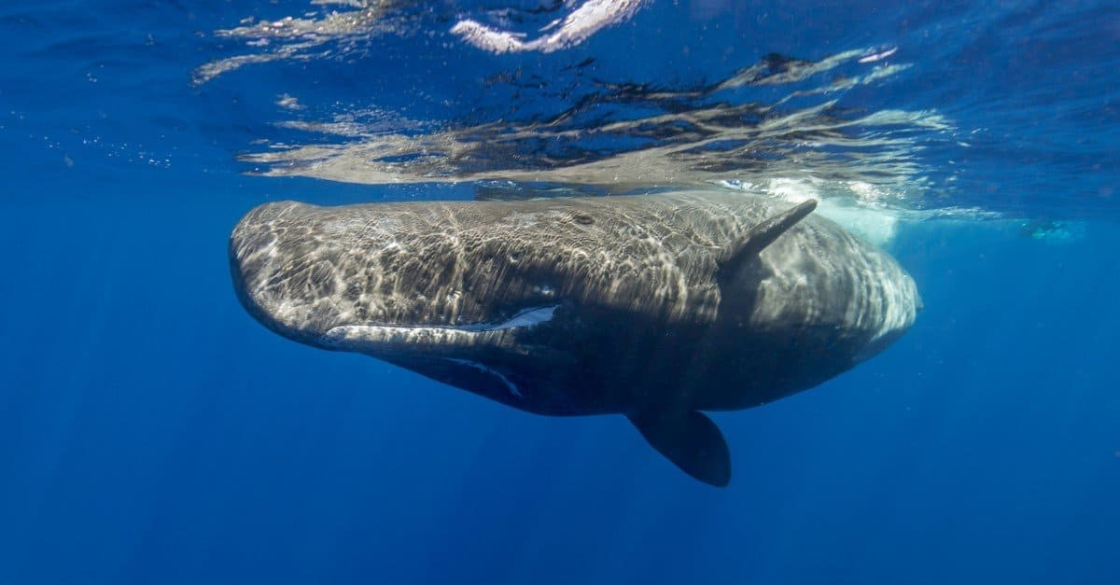

Welcome to the 2027 Yankee Rally!
Held in beautiful Mystic/Groton, Connecticut!
The Mystic area is one of New England's most popular vacation destinations, offering something for everyone. Rich in sailing and whaling history, the region features attractions such as Mystic Seaport Museum and Mystic Aquarium, along with outstanding dining, shopping, and scenic coastal charm.
Just a short drive away, you can enjoy a riverboat cruise and vintage train ride in Essex. Nearby are Foxwoods Resort Casino and Mohegan Sun, as well as the United States Navy's Submarine Base, home to the historic USS Nautilus, the world's first nuclear-powered submarine. The United States Coast Guard Academy is also located in nearby New London.
We will have group rides, along with plenty of opportunities to explore the area's many attractions on your own.
Everyone who submits their rally registration by January 31, 2027, will be entered into a special raffle. More details will be announced on our Facebook page.
On Saturday evening, we'll wrap up our rally with a banquet dinner at the Marriott's beautiful banquet facility. We know you'll enjoy the comfortable accommodations at our host hotel. Then, on Sunday morning, join us for a farewell breakfast before heading home, bringing a memorable Connecticut weekend to a close.
We look forward to welcoming you for a fantastic 2027 Yankee Rally filled with great rides, wonderful friends, and lasting memories!
If you have any questions or concerns, please email us at yankeerallyconnecticut2027@gmail.com

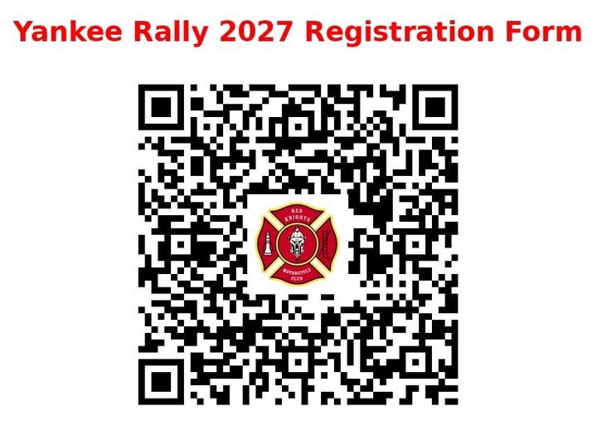
HOST Hotel: Mystic Marriott Hotel & Spa 625 North Road, (Route 117), Groton, CT
Reservations: SCAN the QR Code below, or call (888)-236-2427 no later than May 10, 2027, 4:00 P.M.
Group Name: “Red Knights Yankee Rally”
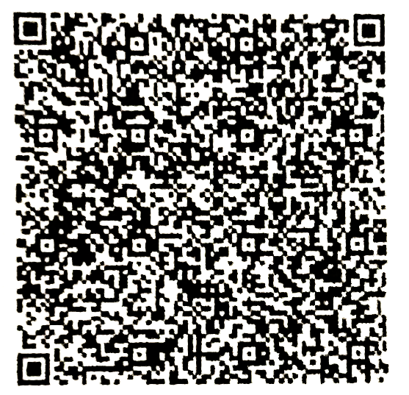

Hope to see You All in Mystic…

